Maduino Zero Lorawan Change Frequence

Author: Vincent

Create Date:2021/9/28

# Introduction

The RA-07H chip cannot modify the Lorawan frequency by AT instruction.

If you buy the 868MHz version and want to use the 915MHz frequency, you need to modify it by burning the firmware.

JLink(V9 version) is required.

# Burning

## Hardware Preparation

Please use JLINK of the new version V9, I have tested it with V8 version and it seems to not connect correctly.

It could also be a fault on my device, but use the latest version of JLink whenever possible.

## Software Preparation

Download JLink software:

<https://www.segger.com/downloads/jlink/>

My version is 6.98a, it may not be necessary.

Install it, and run J-Flash.

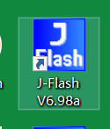

Burn steps

1. Connect cables as follows

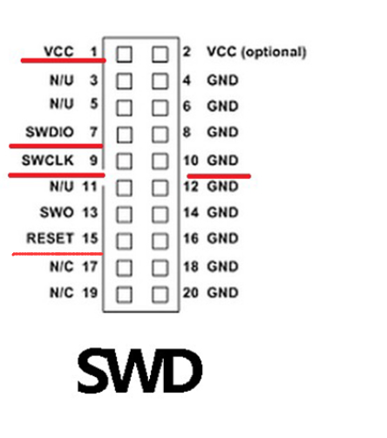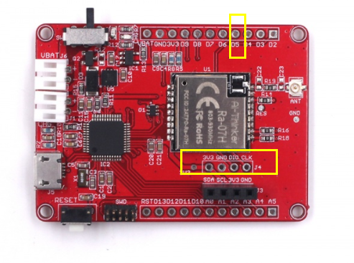

RESET connect to D5.

1. Open JFLASH and select File, New Project

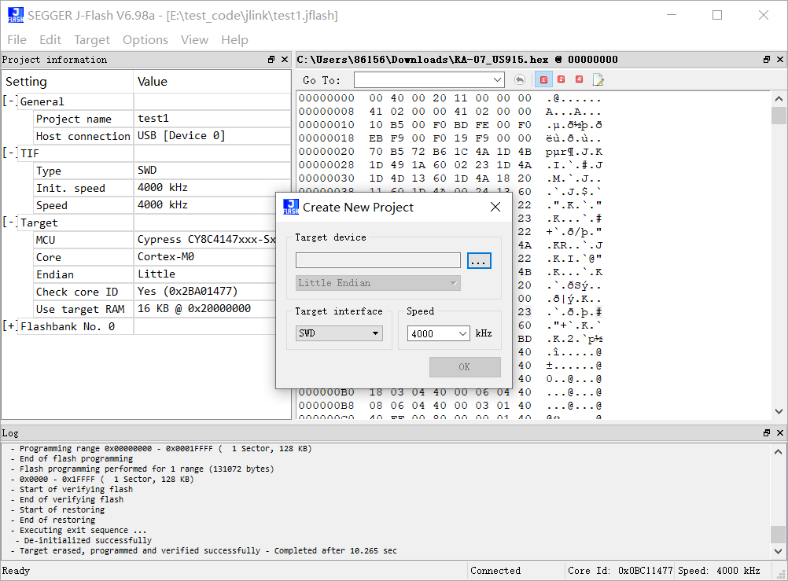

1. Select Cypress cy8c4147XXX-sxxx, select OK, select OK

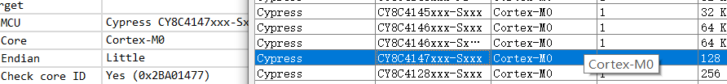

1. Click on Target, select Connect, and the following log bar will display successful connection. If the connection fails, the JLink is faulty or improperly connected.

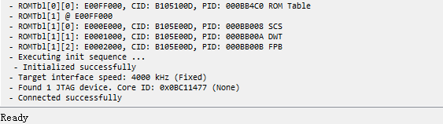

1. Select File, Open Data File to Open the firmware HEX File that needs to be burned.

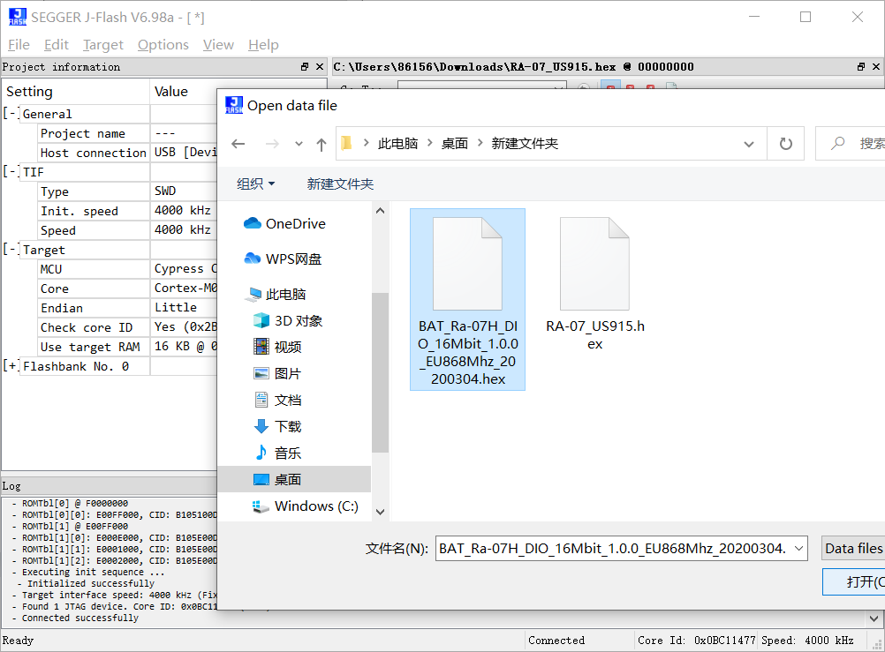

1. Select Target, Production Programming, and download the firmware.

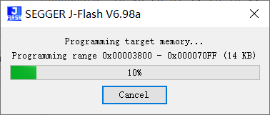

1. Successful download will be prompted

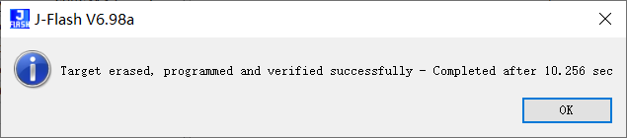

Burn over.